

NAIROBI SCHOOL 2025 PREDICTION
KCSE ANTICIPATION EXAM
312/2
GEOGRAPHY
PAPER 2
TIME: 2¾ HOURS

NAME……………………………………………………………………………………….
SCHOOL……………………………………………… SIGN………………………..
INDEX NO……………………………………………. ADM NO……………………

(Kenya Certificate of Secondary Education)

INSTRUCTIONS TO CANDIDATES
- This paper has two Sections A and B.
- Answer all the questions in Section A.
- In Section B, answer question 6 and any other two questions from Section B.
- All answers must be written in the foolscaps provided.

FOR EXAMINER’S USE ONLY
SECTION | Questions | Maximum Score | SCORE
A | 1-5 | 25
B | 6 | 25
 |  | 25
 |  | 25
 | Total Score | 100%

SECTION A:
Answer ALL questions in this section
1a) Identify two ways in which Geography is related to demography. (2mks)
b) State three significance of studying Geography. (3mks)

2a) What is a forest? (2mks)
b) Give three reasons why the Kenyan government is encouraging afforestation Programme.
(3mks)
3a) Apart from the sun, name two other renewable sources of electricity. (2mks)
b) Give three disadvantages of using solar energy. (3mks)

4. Use the map of the Ruhr Industrial Zone below to answer question that follow.
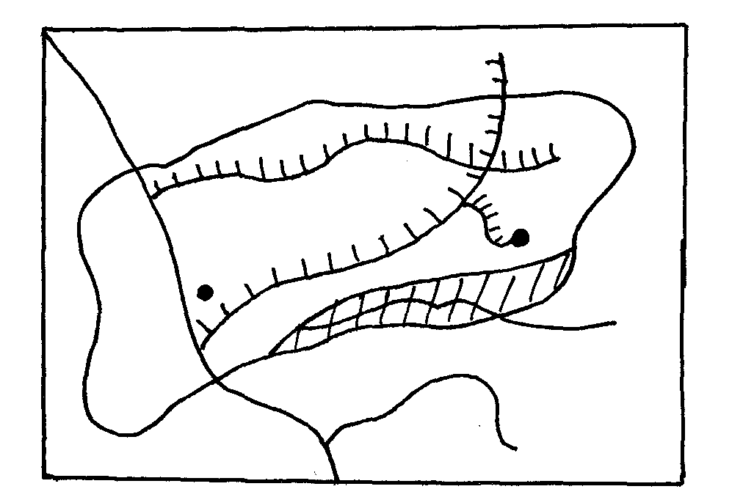
R. Rhine
R. Ruhr
N
K
M

Rheine Herne Canal

a) i) Identify and name:
- The town marked M (1mk)
- The river marked K (1mk)
b) State three physical factors that influenced the location of the iron and steel industry in the Ruhr Region of Germany (3mks)
5. a) Define the term regional trade (2mks)
b) State three challenges facing Common Market of Eastern and Southern Africa (COMESA)
(3mks)

SECTION B: (75 MARKS)
Answer question 6 and any other two questions from this section.
6. The table below shows agricultural crops produced in Kenya in the year 2015 to 2018. Use it to answer question (a).
Crops | Amount in metric tonnes
 | 2015 | 2016 | 2017 | 2018
Tea | 240,000 | 314,000 | 399,000 | 405,000
Coffee | 98,000 | 54,000 | 42,000 | 55,000
Wheat | 70,000 | 37,000 | 54,000 | 66,000
a) i) Using a scale of 1cm to represent 50,000 metric tonnes, draw a comparative bar graph to represent the data above. (8mks)
ii) State two disadvantages of using comparative bar graphs to present data (2mks)
b) Explain three physical conditions that favour tea growing in the Kenyan highlands (6mks)
c) i) Describe the stages involved in the processing of tea from processing to marketing (6mks)
ii) State three problems facing small scale tea farmers in Kenya. (3mks)

7. a) i) Name three ways in which minerals occur within the Earth’s crust. (3mks)
ii) Identify the main minerals mined in the following areas of East Africa.
- Mwadui. (1mk)
- Kariandusi. (1mk)
- Bamburi. (1mk)
b) i) Apart from shaft method of mining give two types of underground mining. (2mks)
ii) Describe the deep shaft method of mining. (6mks)
c) Give three reasons why Kenya imports her oil in crude form (3mks)
d) Explain four ways in which mining contributes to the economy of Kenya. (8mks)

8a) i) Define dairy farming (2mks)
ii) Name three exotic dairy breeds reared in Kenya. (3mks)
b) Explain three reasons why dairy farming is least developed in Northern Kenya. (6mks)
c) Compare dairy farming in Kenya and Denmark under the following sub-headings:
- Breeds (2mks)
- Processing of milk (2mks)
d) Explain three measures the government of Kenya has undertaken to improve small dairy farming (6mks)
e) Give four benefits of dairy farming to the economy of Denmark. (4mks)

9 a) i) Apart from draining swamps, name three other methods used to reclaim land in Kenya.
(3mks)
ii) Identify two examples of swampy areas that have been reclaimed in Kenya. (2mks)
b) Give four physical factors that influenced the location of Mwea-Tebere irrigation scheme. (4mks)
c) i) List three crops grown in the Mwea-Tebere irrigation scheme. (4mks)
ii) State four problems experienced by farmers in Mwea-Tebere irrigation schemes. (4mks)
d) Explain four differences between land reclamation in Kenya and Netherlands. (8mks)

10. a) i) What is a sanctuary. (2mks)
ii) The map below shows the major game reserves and national parks in East Africa.
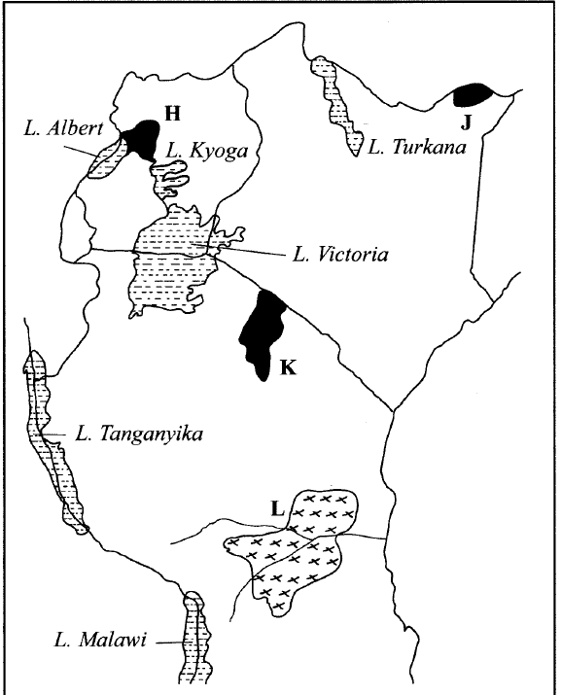

Name the;
- National Parks marked H, J and K. (3mks)
- Game reserve marked L. (1mk)
b) Explain how the following factors affect wildlife industry in Kenya.
i) Poaching. (2mks)
ii) Drought. (2mks)
c) i) Give four factors that hinder domestic tourism in Kenya. (4mks)
ii) State three benefits of ecotourism in Kenya. (3mks)
d) Explain four similarities between tourism in Kenya and Switzerland. (8mks)

